**15/11/2021 ML LAB 11 2019103573**

Implement PCA and LDA. Compare the performance wrt to time and accuracy of MLP and K-means clustering before and after applying dimensionality reduction on any dataset of your choice from UCI repository.

**PRNCIPAL COMPONENTS ANALYSIS (PCA)**

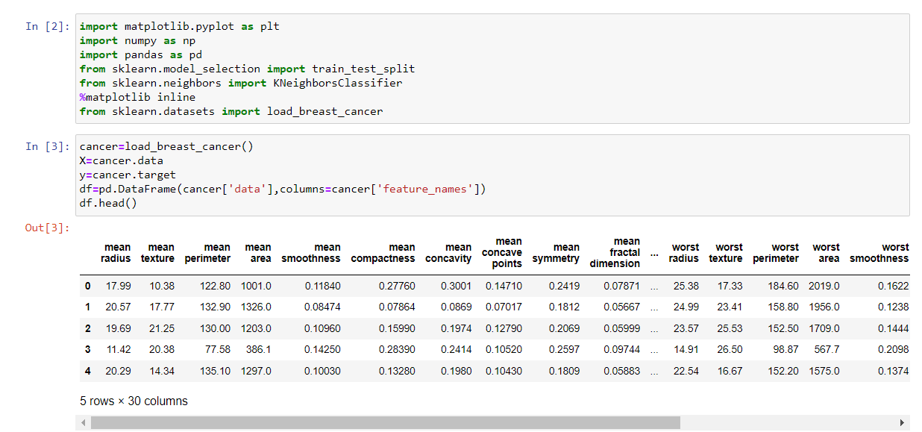

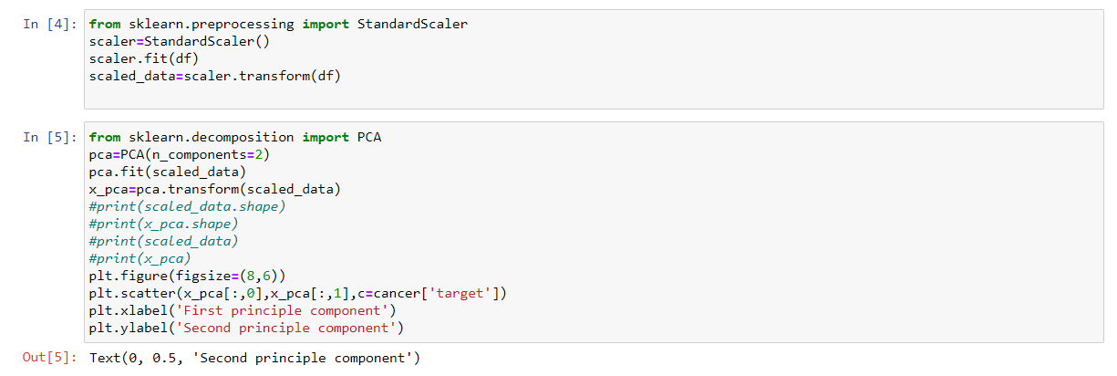

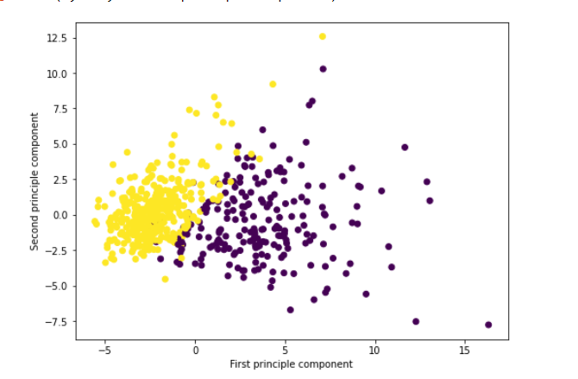

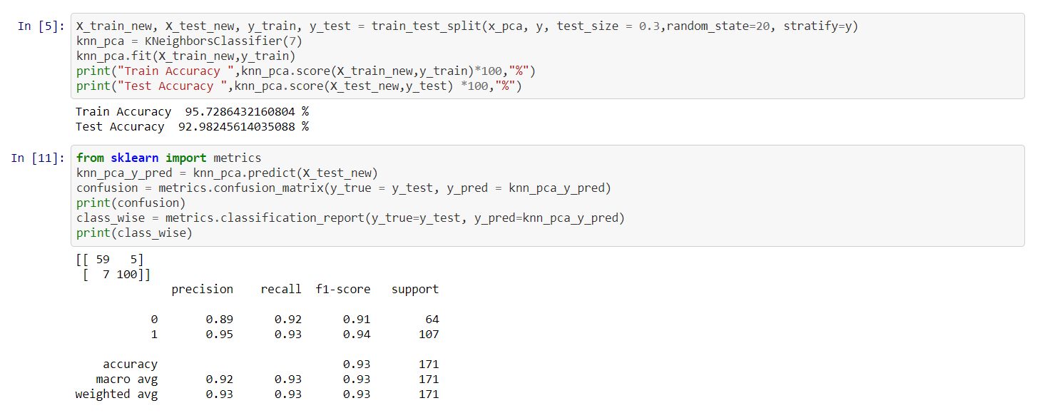

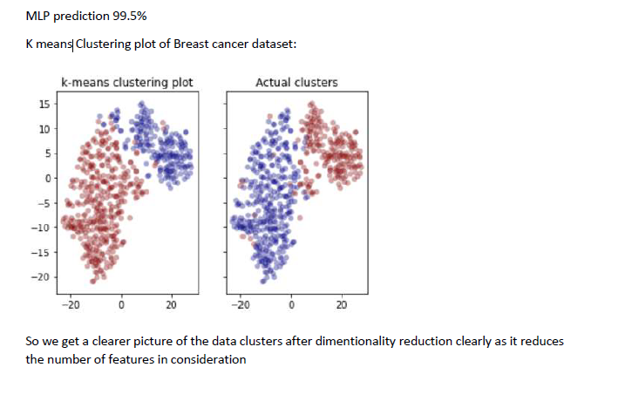

**LINEAR DISCRIMINANT ANALYSIS ( LDA)**

